A PROJECT REPORT ON

# “VOICE BASED EMAIL SYSTEM FOR VISUALLY CHALLENGED PEOPLE”

SUBMITTED TO

SHIVAJI UNIVERSITY, KOLHAPUR

IN THE PARTIAL FULFILLMENT OF REQUIREMENT FOR THE AWARD OF DEGREE

BACHELOR OF TECHNOLOGY IN INFORMATION TECHNOLOGY

SUBMITTED BY

Mr. Chaitanya Vijay Lotake 17UIT12007XX

Ms. Susmita Sukumar Danwade 17UIT11010XX

Ms. Vaishnavi Shrikant Gondkar 17UIT11013XX

Ms. Priya Gangaram Kadam 17UIT11017XX

Ms. Srushti Ajit Khanje 17UIT11021XX

Mr. Vivek Sunil Kushwaha 17UIT42026XX

UNDER THE GUIDANCE OF

## Prof. S. K.Shirgave

DEPARTMENT OF INFORMATION TECHNOLOGY

D.K.T.E. SOCIETY’S TEXTILE AND ENGINEERING INSTITUTE, CHALKARANJI

(An Autonomous Institute, Affiliated to Shivaji University, Kolhapur)

Accredited with 'A+' Grade by NAAC, An ISO 9001: 2015 Certified

## YEAR 2020-2021

**D.K.T.E. SOCIETY’S**

**TEXTILE AND ENGINEERING INSTITUTE, ICHALKARANJI**

(An Autonomous Institute, Affiliated to Shivaji University, Kolhapur)

Accredited with 'A+' Grade by NAAC, An ISO 9001: 2015 Certified

## DEPARTMENT OF INFORMATION TECHNOLOGY

**CERTIFICATE**

This is to certify that, project work entitled

# “VOICE BASED EMAIL SYSTEM FOR VISUALLY CHALLENGED PEOPLE”

is a bonafide record of project work carried out by

Mr. Chaitanya Vijay Lotake 17UIT12007XX

Ms. Susmita Sukumar Danwade 17UIT11010XX

Ms. Vaishnavi Shrikant Gondkar 17UIT11013XX

Ms. Priya Gangaram Kadam 17UIT11017XX

Ms. Srushti Ajit Khanje 17UIT11021XX

Mr. Vivek Sunil Kushwaha 17UIT42026XX

In the partial fulfillment of award of degree, Bachelor of Technology in Information Technology prescribed by Shivaji University, Kolhapur for the academic year 2020-2021.

Prof. S. K. Shirgave (PROJECT GUIDE)

Prof. ( Dr.) D.V.KODAVADE Prof.(Dr.) P.V.KADOLE (H.O.D. C.S.E.) (DIRECTOR)

EXAMINER

# DECLARATION

We hereby declare that, the project work report entitled **“VOICE BASED EMAIL SYSTEM FOR VISUALLY CHALLENGED PEOPLE”** which is being submitted to D.K.T.E. Society’s Textile and Engineering Institute Ichalkaranji, affiliated to Shivaji University,Kolhapur is in partial fulfillment of degree B.TECH.(IT). It is a bonafide report of the work carried out by us. The material contained in this report has not been submitted to any university or institution for the award of any degree. Further, we declare that we have not violated any of the provisions under Copyright and Piracy / Cyber / IPR Act amended from time to time.

**PRN Name Signature**

17UIT12007XX Mr. Chaitanya Vijay Lotake

17UIT11010XX Ms. Susmita Sukumar Danwade

17UIT11013XX Ms. Viashnavi Shrikant Gondkar

17UIT11017XX Ms. Priya Gangaram Kadam

17UIT11021XX Ms. Srushti Ajit Khanje

17UIT42026XX Mr. Vivek Sunil Kushwaha

# ACKNOWLEDGEMENT

With great pleasure we wish to express our deep sense of gratitude to Mr. S.K. Shirgave for his valuable guidance, support and encouragement in completion of this project report.

Also, we would like to take opportunity to thank our head of department Dr.D. V. Kodavade for his co-operation in preparing this project report.

We feel gratified to record our cordial thanks to other staff members of Information Technology Department for their support, help and assistance which they extended as and when required.

Thank you,

Mr. Chaitanya Vijay Lotake 17UIT12007XX

Ms. Susmita Sukumar Danwade 17UIT11010XX

Ms. Viashnavi Shrikant Gondkar 17UIT11013XX

Ms. Priya Gangaram Kadam 17UIT11017XX

Ms. Srushti Ajit Khanje 17UIT11021XX

Mr. Vivek Sunil Kushwaha 17UIT42026XX

# ABSTRACT

To develop a completely voice based system that will help visually challenged individuals to access email system in a problem free manner. Blind people face difficulties in accessing such systems provided through internet. The advancement in computer-based accessible systems has helped the visually impaired across the globe in a wide way. Audio feedback based virtual environment like, the screen readers have helped blind people to access the internet applications immensely. Similarly, the thought behind this ‘Voice based Email system’ is designed to be used by a blind person to access e-mails easily and efficiently.

**INDEX**

1. **Introduction 2**
2. **Problem Description 3**
   1. Problem definition 3
   2. Aim and objective of the project 3
   3. Scope and limitation of the project 3
3. **Background Study and Literature Overview 5**
   1. Literature overview

1. Technology review 6

2. Literature review 6

1. **Requirement Analysis 9**
   1. System requirement 10
   2. Functional requirement 11
   3. Analysis 12
2. **System Design 13**
   1. Architectural Design 14
   2. Data Design 15
      1. Use case Diagram 15
      2. Data flow diagram 16
      3. Sequence diagram 18
      4. Activity diagram 19
      5. Deployment diagram 21
3. **Implementation 22**
   1. Detailed Description of Method 23
   2. Methodology 26
4. **Integration and Testing 28**
5. **Performance Analysis 31**
6. **Applications 33**
7. **Installation Guide and User Manual 35**
8. **Cost Estimation 39**
9. **Ethics 41**
10. **References 43**

# Introduction

E-mails are considered to be the most reliable way of communication over Internet, for sending or receiving some important information. But there is a special criterion for humans to access the Internet and the criteria is you must be able to see. You must be thinking that what sort of criteria is this, everyone with eyes can see. But there are also specially challenged people in our society who are not gifted with what you have. Yes, there are some visually challenged people or blind people who cannot see things and computer screen or keyboard. A survey shows that there are more than 250 million visually challenged people around the globe. That is, around 250 million people are unaware of how to use Internet or E-mail. The only way by which a visually impaired person can send an E-mail is, they have to dictate the entire content of the mail to a third person (not visually challenged) and then the third person will compose the mail and send on the behalf of the visually impaired person. But this is not a correct way to deal with this problem. It is very less likely that every time a visually challenged person can find someone for help. Although for these reasons the specially-challenged people are criticized by our society.

#### Problem definition:

A voice enabled E-mail service to help visually challenged people.

#### Aim and objectives of the Project :

As the title suggest the application will be a web-based application for visually impaired persons using IVR- Interactive Voice Response, thus enabling everyone to control their mail accounts using their voice only and to be able to read, send and perform all the other useful tasks.

1. To let a visually impaired person login to the email service securely and without any assistance from other person.
2. To allow a user to send and receive email following the directions of the chatbot.
3. To make the user read the received email with the help of the chatbot.

#### Scope and limitations of the Project :

There are several limitations of the present system.Although composing a mail through voice is easy, however, in the present version of the system a blind person has to enter the recipient’s mail address through keyboard. This ultimately requires the knowledge of the keyboard. We can partially solve this problem by integrating a separate conﬁguration GUI with the present system. Through the conﬁguration GUI, a Blind person can associate a voice-based nick name corresponding to each recipient mail id and during composing a mail, the mail ids of the recipients can be searched through the list of these voice-based nick names. The disadvantages of the existing system are as follows:

1. Screen readers cannot spell technical and biological terms.
2. Braille language must be known and when using keyboards shortcuts need to be notified.
3. Fingerprint authentication can be easily acquired through any malpractices.
4. Since the systems are web and desktop applications, they cannot be used by visually challenged without some help.

# Background Study

**and**

**Literature Overview**

## 2 . Literature Overview

##### **Literature Overview:**

1. Technology review:

There is a rich literature on the technological advances in building assistive tools for the visually impaired people. These include development of text to ***Braille systems, screen magniﬁers and screen readers.*** Recently, attempts have been made in order to develop tools and technologies to help blind people to access internet technologies. Among the early attempts, voice input and input for surﬁng was adopted for the Blind people.IBM’s Home Page Reader, presents the web page in an easy-to-use interface, and converts the text-to-speech, having different gender voices for reading texts and links. However, the disadvantage of this is that the developer has to design a complex new interface for the complex graphical web pages to be browsed and for the screen reader to recognize.

1. Literature review:

[1] Tirthankar Dasgupta, “Voice Mail Architecture in Desktop and Mobile Devices for the Blind People”, 2012.

The advancement in computer based accessible systems has opened up many avenues for the visually impaired across a wide majority of the globe. Audio feedback based virtual environment like, the screen readers have helped Blind people to access internet applications immensely. However, a large section of visually impaired people in different countries in particular, the Indian sub-continent could not benefit much from such systems. In this paper, we describe the Voice Mail system architecture that can be used by a Blind person to access e-Mails easily and efficiently.

[2] Amritha Suresh, Binny Paulose, Reshma Jagan and Joby George, "Voice Based Email for Blind".

A voice based email architecture is proposed which will help blind people to access email. The existing system is not user friendly for blind people as it does not give any audio feedback to readout contents for them. The proposed system makes use of Speech Recognition, Interactive Voice Response and Mouse Click events. Also, for additional security purposes voice recognition is used for user verification. In this system, Registration is the first module. This module will collect complete information of the user by prompting the user to what details need to be entered. The second module is the login module in which the system will ask the user to provide user name and password. This is done through voice commands. Another voice sample is asked for performing the voice verification. Then the user is redirected to the inbox page once login is done. After login, users can perform normal operations of a mailing system. System options are: Compose, Inbox, Sent Mail, Trash. The user can switch between these using voice commands.

[3] Pranjal Ingle, Harshada Kanade and Arti Lanke, "Voice Based email System for Blinds".

The system uses mainly three technologies:

● Speech to text

● Text to Speech.

● Interactive Voice Response.

When the user visits the site for the first time he/she would need to register through voice commands. Also after registration, the user's voice will also be recorded and stored in the database. And the user will get an Id and password. After login, the user can access the mail option. In this system. The user interface is designed using Adobe Dreamweaver CS3. The complete website mainly focuses on efficiency in understanding.

# Requirement Analysis

## System Requirement

##### Software and Hardware requirements :

* Hardware requirement :
  + Personal Computer with standard configuration
  + RAM – minimum 4GB
  + Processor – Intel Core i3 or higher
  + Storage – minimum 80GB
  + Microphone
  + Speaker
* Software requirements :
  + Operating System – Windows7 or higher.
  + Python3
* Xampp server
* Mysql database

## Functional Requirements:

* User Login

The admin tried to make the login process a little more secure by adding the Security number. The user speaks his name which will be his user id after which the system will ask the user for a security number that only user is supposed to know. If the user id and the corresponding security number matches then the system will log in the user to email dashboard. If it doesn’t match then the system will send the user back to “login” or “exit” option.

* Compose the mail

The system will ask for the recipient’s name. The recipient’s name is actually stored in the system under the rname. The system will search for the rname in the database and add its corresponding email id in the recipient’s section of the mail. The system will use the Google text to speech API to convert he speech of user into text and add it to the body of the mail. If the user wishes to change the body of the mail in mid-sentence he/she can say “change” and the system will rewrite the body. After the user has finished speaking it will send the mail to the recipient and logout the user from the system.

* Read the inbox

The system will read the unread emails one by one.

## Analysis

Analysis of mail.search()method isdonein thisproject. The procedureanddrawback isexplainedas follows:

###### Unseen mails:

For status,

unseen = mail.search(None, 'UNSEEN')

There is a one drawback. If there are no unseen mails, then it returns the number of unseen mails correctly, which is zero. But if there are unseen mails so instead of count of unseen emails the module returns the total count of emails.

# System Design

## 4. System Design

Architectural Design of System :-

Figure 4.1 shows architectural diagram of a system. Architectural diagram shows abstract and the overall outline of the email system and the relationships between user and system.

Rectangle symbolizes the user of the system. Ellipse represent the functionalities. The user and the functionalities are connected to each other based on the constraints.

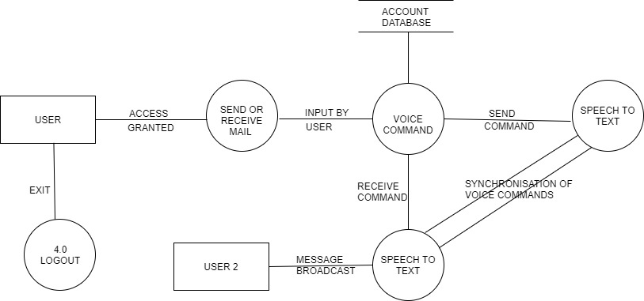

4.1 . Architectural Design of System

**Data Design**

**Use case diagram:-**

Figure 4.2 shows the Use case Diagram of the system.Use-case diagram is a pictorial representation of the actor’s interaction with different functionalies.This diagram represents the activities used to reach the goal.

The stick figures represent the users/admin of the system. Ecllipse shows the functionalities of the system. Straight line shows the association between actors and the functionalities.

**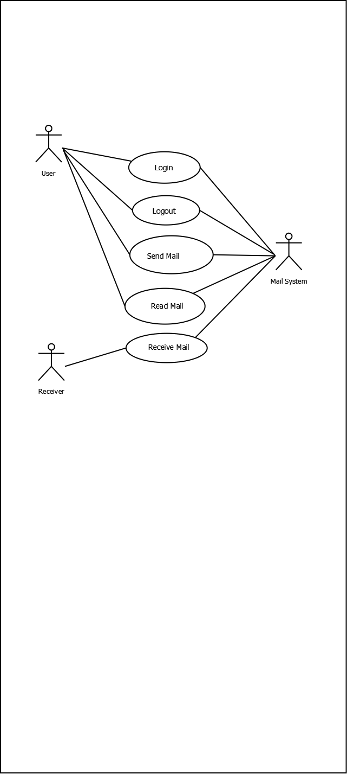**

4.2 Use-case:

* + 1. **DataFlowDiagram:-**Figure 4.3.1 shows the Level-0 Data flow diagram of the system.This shows the lowest level of the flow of the system. This diagram shows the whole system as a single process and emphasizes the interaction between the system and external entities. It shows the abstract view of the system. Input and output data is indicated by incoming/outgoing arrows

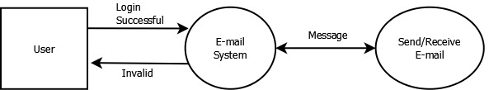

4.3.1 Level-0DataFlowDiagram

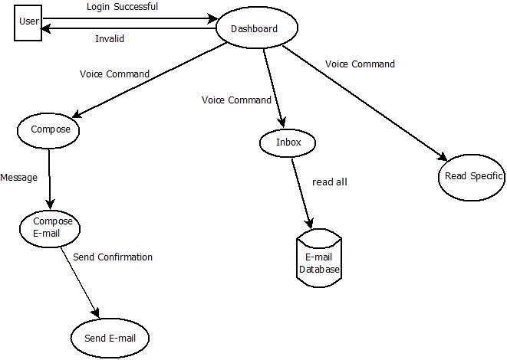

4.3.2 Level**-**1DataFlowDiagram

**Figure 4.3.1** shows the Level-1 Data flow diagram of the system. This simply breaks processes down into more detailed sub-processes. It visualizes high level overview of the system.This highlights main functions of a system. This helps to visualize incoming data flow, processes and output data flows.

###### Sequence Diagram:

The Figure 4.4 shows the sequence diagram of the system.It is a type of interaction diagram because it describes howand in what ordera group of objects works together. This shows the requirements for a new system or to document an existing process. It shows the interaction logic between the objects in the system in the time order that the interactions take place.

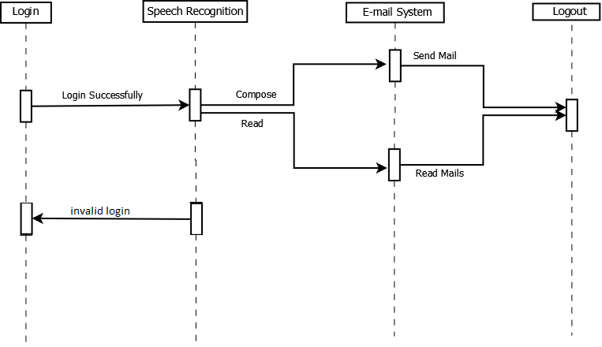

4.4 Sequence Diagram:

**Activity Diagram:**

The figure 4.5 shows the Activity Diagram of the sytem.This is a behavioral diagram i.e. it depicts the behavior of a system. It portrays the control flow from a start point to a finish point of the system showing the various decision paths that exist while a certain activity is being executed.This visually represents a series of actions or flow of control in a system similar to a flowchart or a data flow diagram.

**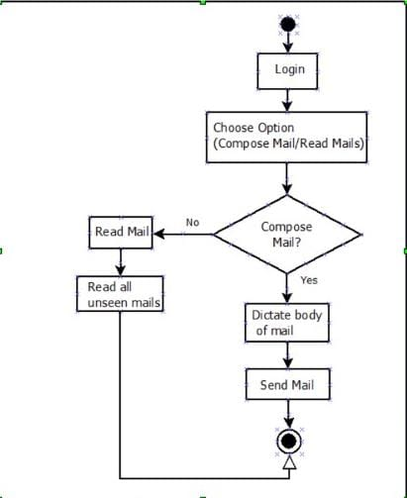**

4.5 Activity Diagram:

* + 1. **Deployment Diagram:**

The Figure 4.6 shows the deployment diagram of the system.This is a UML diagram type that shows the execution architecture of a system, including nodes as user and final goal and the middleware system connecting them. This diagram is typically used to visualize the physical hardware and software of a system. A line indicates the communication between the nodes and the middleware.

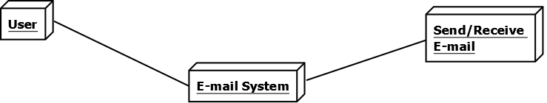

4.6 Deployment Diagram

# Implementation

## **Detailed Description of Methods**

* **Implementation -**
  1. Preprocessing of Data:

The preprocessing of the data required for the email system is that the Speech must be converted from physical sound to an electrical signal with a microphone, and then to digital data with an analog-to-digital converter. Once digitized, several models can be used to transcribe the audio to text.

* 1. Speech Recognition:

SpeechRecognition package and use its Recognizer class to easily recognize speech from both a file—using record()—and microphone input—using listen().

The Recognizer Class:The primary purpose of a Recognizer instance is to recognize speech. Each instance comes with a variety of settings and functionality for recognizing speech from an audio source.

The Microphone Class:

Open up another interpreter session and create an instance of the recognizer class. Now, instead of using an audio file as the source, you will use the default system microphone. You can access this by creating an instance of the Microphone class.

Using listen() to Capture Microphone Input:

Now that you’ve got a Microphone instance ready to go, it’s time to capture some input.  
  
Just like the AudioFile class, Microphone is a context manager. You can capture input from the microphone using the listen() method of the Recognizer class inside of the with block. This method takes an audio source as its first argument and records input from the source until silence is detected.  
  
>>>with mic as source:  
...     audio = r.listen(source)  
...  
Once you execute the with block, try speaking “hello” into your microphone. Wait a moment for the interpreter prompt to display again. Once the “>>>” prompt returns, you’re ready to recognize the speech.

Next, recognize\_google() is called to transcribe any speech in the recording. A try...except block is used to catch the RequestError and UnknownValueError exceptions and handle them accordingly. The success of the API request, any error messages, and the transcribed speech are stored in the success, error and transcription keys of the response dictionary, which is returned by the recognize\_speech\_from\_mic() function.

* 1. Working of Email sytem:

The voice based email system can send,read and receive emails form users. The email is sent and received using IMAP and SMTP servers.

SMTP:

An [SMTP](https://docs.python.org/3/library/smtplib.html" \l "smtplib.SMTP" \o "smtplib.SMTP) instance encapsulates an SMTP connection. It has methods that support a full repertoire of SMTP and ESMTP operations.

SMTP.**ehlo**()

This is used to Identify yourself to an ESMTP server using EHLO. The hostname argument defaults to the fully qualified domain name of the local host.

SMTP.**login**(*user*, *password*, *\**, *initial\_response\_ok=True*)

Log in on an SMTP server that requires authentication. The arguments are the username and the password to authenticate with.

IMAP:

IMAP is an email retrieval protocol which does not download the emails. It just reads them and displays them.

IMAP4.**select**(*mailbox='INBOX'*, *readonly=False*)

Select a mailbox. Returned data is the count of messages in *mailbox* (EXISTS response). The default *mailbox* is 'INBOX'. If the *readonly* flag is set, modifications to the mailbox are not allowed.

b)METHODOLOGY:

1.Preprocessing:

1. Data Analysis:

Data is converted from text to speech and viceversa.

1. Google text to speech:

**gTTS** (Google Text-to-Speech), a Python library and CLI tool to interface with Google Translate’s text-to-speech API. Writes spoken mp3 data to a file, a file-like object (bytestring) for further audio manipulation, or stdout.

The tts.save() function allows us to save the converted speech in a format that allows us to play sounds.

1. Pyglet.media:

using the **[pyglet.media.load()](https://pyglet.readthedocs.io/en/latest/modules/media.html" \l "pyglet.media.load" \o "pyglet.media.load)** function,the media file is bundled with the application.The result of loading a media file is a **[Source](https://pyglet.readthedocs.io/en/latest/modules/media.html" \l "pyglet.media.Source" \o "pyglet.media.Source)** object.However if “StreamingSource=False” is used then the object returnes is of StaticSource.

Streaming Source:A source that is decoded as it is being played.The source can only be played once at a time on any **[Player](https://pyglet.readthedocs.io/en/latest/modules/media.html" \l "pyglet.media.player.Player" \o "pyglet.media.player.Player)**.

 Call the **[play()](https://pyglet.readthedocs.io/en/latest/modules/media.html" \l "pyglet.media.Source.play" \o "pyglet.media.Source.play)** method . The return value of **[play()](https://pyglet.readthedocs.io/en/latest/modules/media.html" \l "pyglet.media.Source.play" \o "pyglet.media.Source.play)** is a **[Player](https://pyglet.readthedocs.io/en/latest/modules/media.html" \l "pyglet.media.player.Player" \o "pyglet.media.player.Player)**, which can either be discarded, or retained to maintain control over the sound’s playback.

# Integration

# And Testing

## Integration and Testing

## Login (30 sec)- User will say login and speak his/her name. The system will ask for security number. User will speak the credentials.

## Output – User will be directed to the mail dashboard with successful login.(if the credentials are correct)

## Compose mail (1-2 mins) – System will ask for recipient’s name.User has to speak the content of the mail. System will ask for the content confirmation.

## Output – Email will be sent.

## Read mail (2-3\_mins) – System will give the count of unseen mails in the inbox (if any) and start to read them.

## Output – Unseen mails are read out by the system.

Test Plan :

|  |  |  |  |
| --- | --- | --- | --- |
| Test no | Test case objective | Test case description | Expected result |
| 1 | Check link between login and module | Say login and speak the user id and security number | To be directed towards mail dashboard. |
| 2 | Check link between mail system and compose mail | Speak recipient’s name and body of the mail. | Email should be sent. |
| 3 | Check link between mail system and read mail | speak the read mail option | Unread emails are read out loud. |

# Performance Analysis

Performance analysis:

Performance analysis is a measure of the success or failure of a project using various parameters. Following table shows the performance of the functionalities of the system in terms of time(in minutes or seconds.)

1. Time

|  |  |
| --- | --- |
| **Methods** | **Time Required** |
| Login | 30sec |
| Compose a mail | 1-2 min |
| Read mails | 2-3min |
| Logout | <10sec |

# Applications

**Applications**

* The option of sending voice messages will not only help

a Blind person to access email but also to a physically impaired user.

* Can be used for making email handling process a little easier for visually challenged people
* This project is proposed for the betterment of society. This project aims to help the visually impaired people to be a part of growing digital India by using internet and also aims to make life of such people quite easy. Also, the success of this project will also encourage developers to build something more useful for visually impaired or illiterate people, who also deserve an equal standard in society.

# Installation Guide and User Manual

### Installation:-

### To install python:

1. Install the python.exe file on your computer from the official site.
2. Open CMD and change Your directory to the path where you have python.exe
3. Past this code in your Command prompt make sure to change the name with your file version In the below code(e.g python-3.8.5.exe)

python-3.6.0.exe /quiet InstallAllUsers=1 PrependPath=1 Include\_test=0

To install the Libraries-

Open command prompt.2. Install the following libraries.

Steps toinstalllibraries-

* Pip install speech\_recognition
* pip install smtplib
* pip install pyaudio
* pip install platform
* pip install sys
* pip install BeautifulSoup
* pip install email
* pip install imaplib
* pip install gTTS
* pip install pyglet
* pip install os, time
* pip install mysql
* pip install mysql.connector
* pip install decode\_header
* pip install web browser

TO install XAMPP server:

**Step 1**

To download the XAMPP server, visit the "[Apache Friends](https://www.apachefriends.org/index.html" \t "_blank)" website in your web browser.

**Step 2**

Click on "XAMPP for Windows". Then, navigate the downloading location and the file will be automatically downloaded.

**Step 3**

Double-click the downloaded file to launch the XAMPP installer.

**Step 4**

"Setup" window will appear on the screen. Then, click on the "Next" button.

**Step 5**

Select the components that you want to install and click on the "Next" button.

**Note** :By default, all components are selected in your XAMPP installation.

**Step 6**

Choose a folder to install the XAMPP and click on the "Next" button.

**Step 7**

Uncheck the "Learn more about Bitnami for XAMPP" option and click on the "Next" button.

**Step 8**

"Ready to Install" window will appear on the screen, then click on the "Next" button.

**Step 9**

Click on the "Finish" button.

**Step 10**

Select a language. (either English or German) and click on the "Save" button.

# Cost Estimation

ProjectCost

Project [cost estimation](https://www.costengineering.eu/cost-estimating-services" \t "_blank) is the process of predicting the quantity, cost, and price of the resources required by the scope of a project. Since cost estimation is about the prediction of costs rather than counting the actual cost, a certain degree of uncertainty is involved. Given below is the Rough order of magnitude type of cost estimation. For this project no external resources were used. Rough order of magnitude gives a less accurate cost estimation. Since no extra resources were required, this type of cost estimation is used.

* 1. Hardware Cost:

|  |  |
| --- | --- |
| **Hardware** | **Cost** |
| ComputerSystem | Rs.25000/- |
| Internet | Rs.2000/- |
| LightSource | Rs.300/- |
| Total | Rs.27300/- |

# Ethics

#### Declaration of Ethics

As a Information Technology Student, I,believe it is Unethical To,

1. Make a copy of software for personal or commercial use
2. Make a copy of software for a friend
3. Loan CDs of software to friends
4. Download pirated software from the internet
5. Distribute pirated software from the internet
6. Buy software with a single user license and then install it on multiple Computers
7. Share a pirated copy of software
8. Install a pirated copy of software

# References

1. T. Dasgupta & A. Basu, “A Speech Enabled Indian Language Text to Braille Transliteration System*”, In Information And Communication Technologies & Development (ICTD), 2009 International Conference On, Pages 201211. IEEE, 2009.*
2. Amritha Suresh, Binny Paulose, Reshma Jagan and Joby George, "Voice Based Email for Blind". *International Journal of Scientific Research in Science, Engineering and Technology (IJSRSET ) - Volume 2, Issue 3, 2016, pp. 93-97.*
3. Pranjal Ingle, HarshadaKanade and Arti Lanke, "Voice Based email System for Blinds". *International Journal of Research Studies in Computer Science and Engineering (IJRSCSE)- Volume 3, Issue 1, 2016, pp. 25-30.*
4. M. N. Kumar, P. C. L. Chandar, A. V. Prasad and K. Sumangali, "Android based educational Chatbot for visually impaired people," 2016 *IEEE International Conference on Computational Intelligence and Computing Research (ICCIC), 2016, pp. 1-4, doi: 10.1109/ICCIC.2016.7919664.*